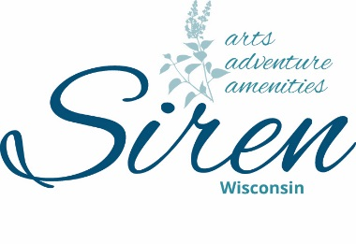
Siren Chamber of Commerce, Inc.
PO Box 57
Siren, WI 54872
715-349-8399
chamber@visitsiren.com

Siren Chamber of Commerce Board Meeting Agenda
July 11th, 2023, at 9:00 am
Future meeting days/times: Second Monday of the Month; 12:00PM, Village Hall

“The mission of the Siren Chamber of Commerce is to assist local businesses
and our community to grow and prosper.”

Attending Board Members: Chris Sybers, Sara Reimann, Dave Alden, Dr. Shelter, Wayne Koball, Josie Woodman, Peggy Orman, Becky Popp, Jenni Smith

Call to Order: Wayne called the meeting to order at 9:00am.
Approval of the Treasury Report: P&L
Approval of Minutes from December 10th, 2022, Dave made a motion to accept as read. Chris 2nd motion. M/C
Approval of Agenda no quorum open discussion only
Old Business:
- Social Media Updates: Sara will give updates including website update including a website status update. Advertising on social media helped for 4th of July. Over 9000 views.
- Volunteers: Volunteers needed for the golf outing. Got enough.
- Additional Board Members: Discussion regarding candidates. Will get 2-3 nominations to turn in for annual meeting.
- 4th of July: What went well and what needs to be done differently next year? A big thank you to Jenni for all her work. Doing a list for next year’s parade for the village chief and others so nothing is missed going forward. PA system is working very well. In June sign up for parade- add on you must have someone to throw out candy. There were issues this year. Will check on fees for vendors. Send out Thank You notes to the ones that put in extra.
New Business:
- Annual Dinner: Set a Date: At event Center Date 9/12 @ 5pm
- Parade Organizers: Thank you from the Chamber. Discussed with old Business
- S-240 Form: The Chamber(or any Organization holding an event) is required to submit this form for Harvestfest. The form requires a WI seller’s Permit Number for each vendor. Most of the vendors that attended Harvestfest 2022 did not have a WI Seller’s permit. Discussion about number of vendors needed to continue Harvestfest. This will be enforced or vendors will not be able to attend.

- Next Board Meeting: July 11th at 9am, 2023, at 9am Village Hall.
Meeting Adjourn: Chris made a motion. Becky 2nd motion. M/C
Josie Penberthy, Submitted

